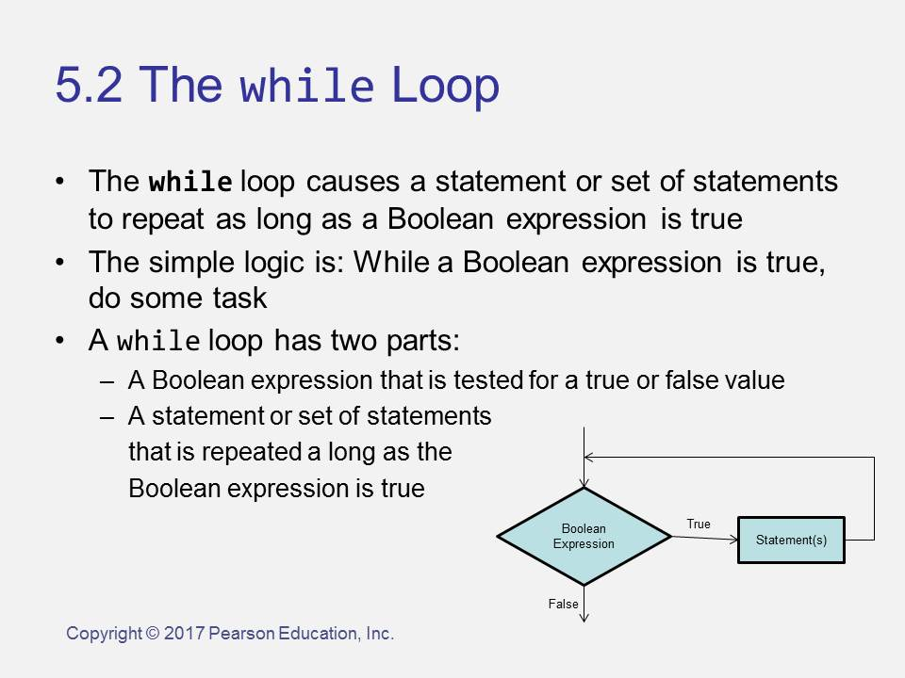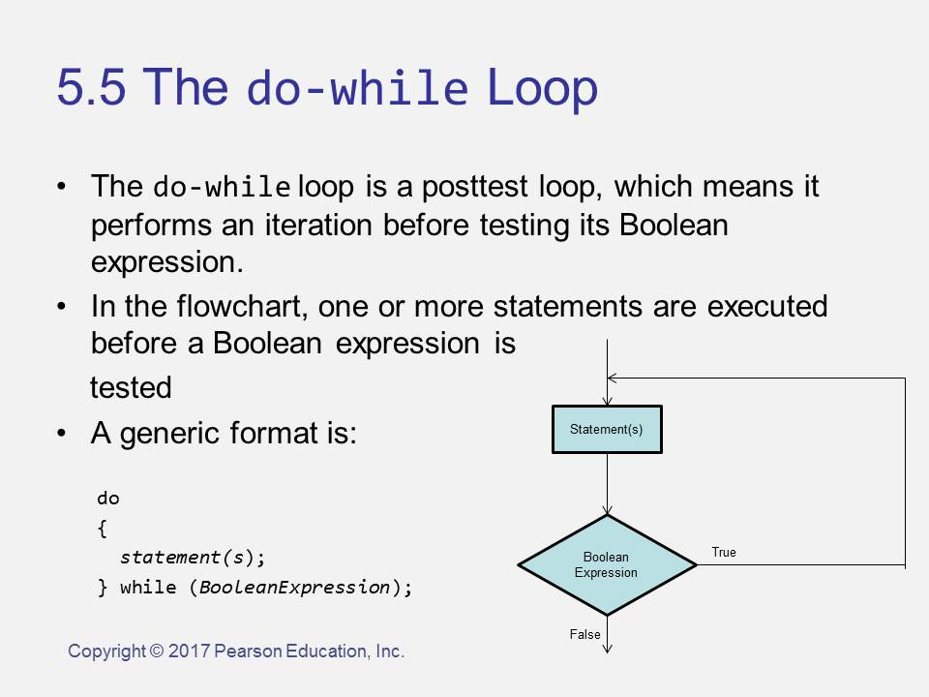 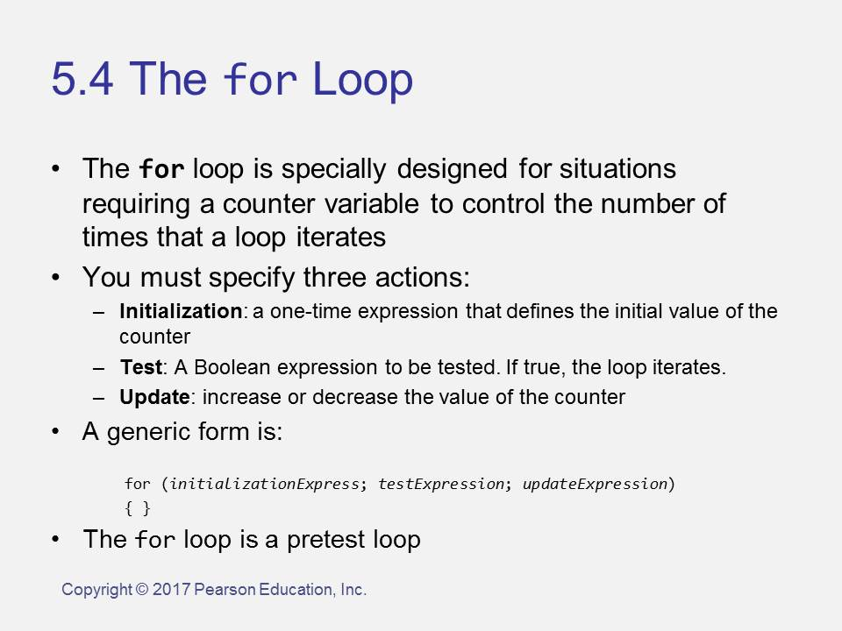

Else

**LOOPS run code a number of times like – LIKE THE IF they have a TEST**

True –

{  
DO this WORK  
}

Tests:  
**> greater than  
<=   
< less than  
>=  
== equal   
!= not equal**

An if statement – code follows different path – based on a test-   
if (TEST)  
{  
 /* statement(s) will execute if the TEST is true */  
}

**TEST**

False –

Continue here